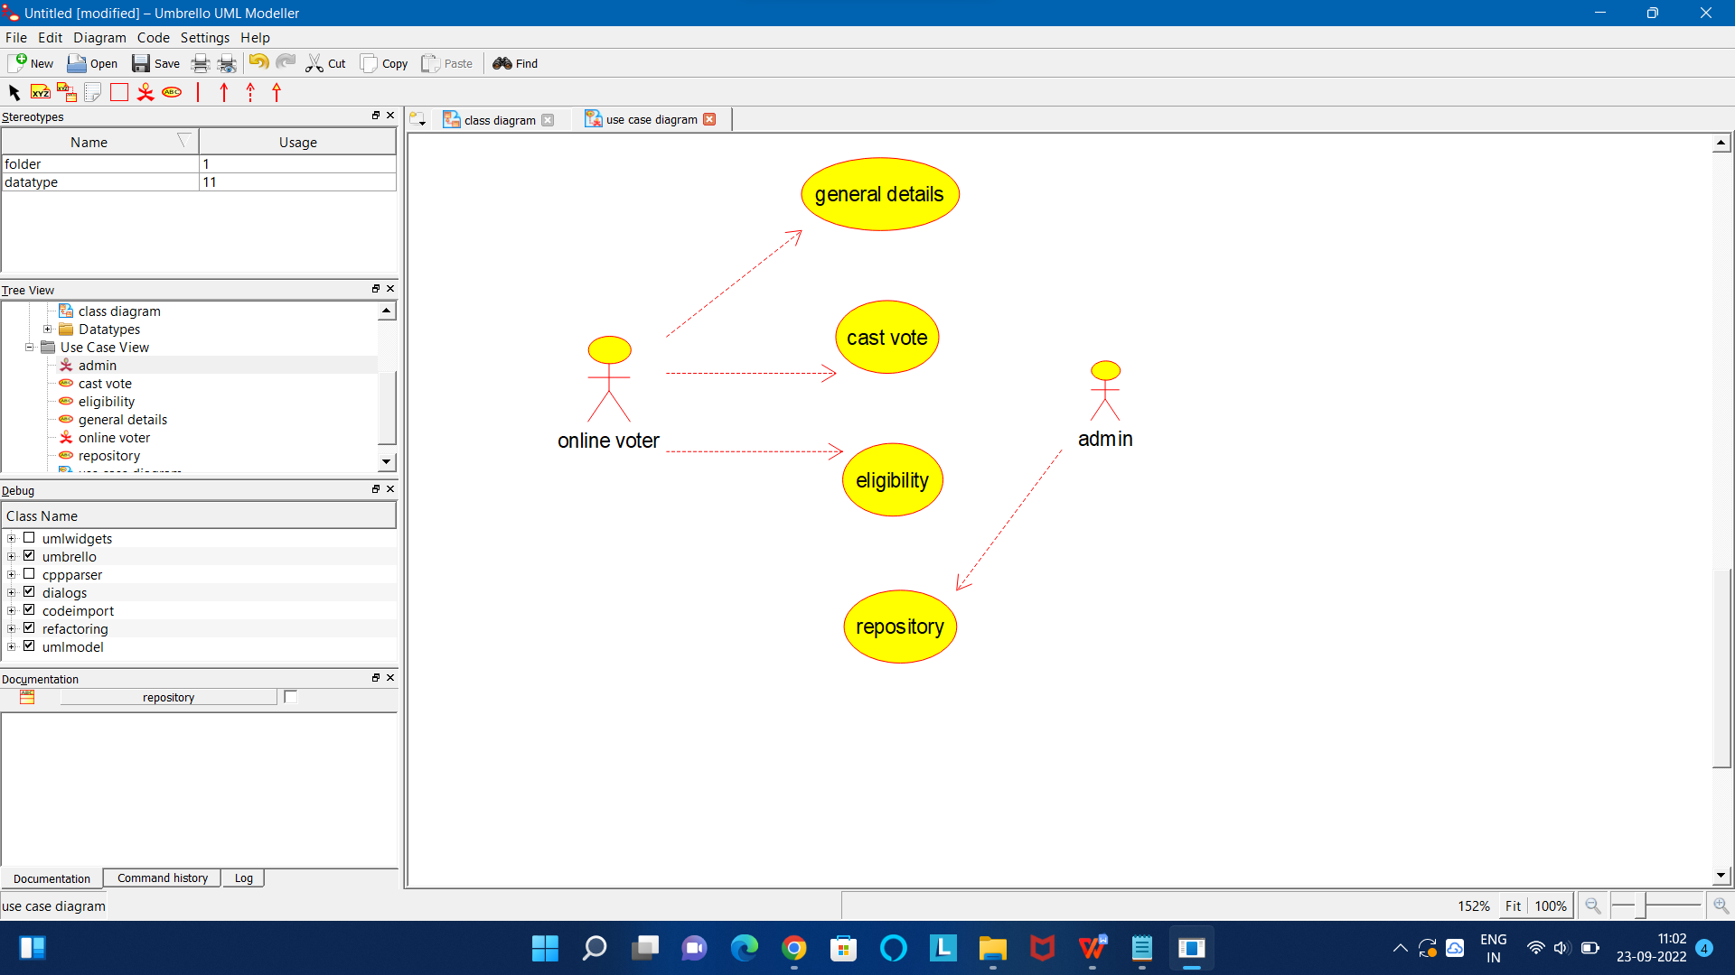

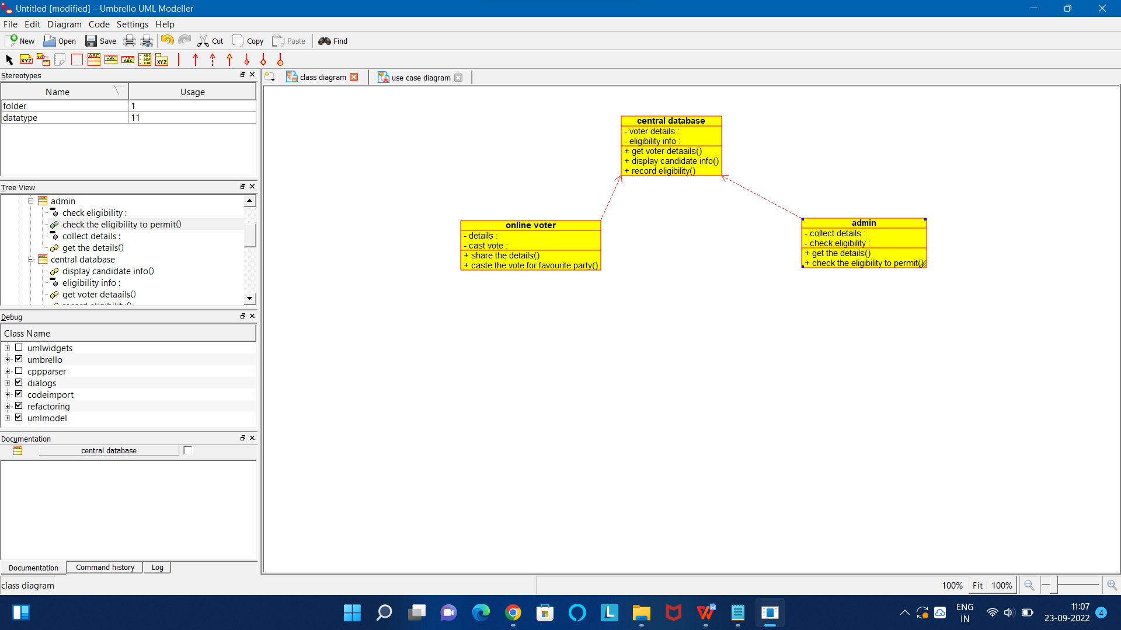

CODE FOR ONLINE VOTER:

/**

* Class online_voter

*/

public class online_voter {

//

// Fields

//

private void details;

private void cast_vote;

//

// Constructors

//

public online_voter () { };

//

// Methods

//

//

// Accessor methods

//

/**

* Set the value of details

* @param newVar the new value of details

*/

private void setDetails (void newVar) {

details = newVar;

}

/**

* Get the value of details

* @return the value of details

*/

private void getDetails () {

return details;

}

/**

* Set the value of cast_vote

* @param newVar the new value of cast_vote

*/

private void setCast_vote (void newVar) {

cast_vote = newVar;

}

/**

* Get the value of cast_vote

* @return the value of cast_vote

*/

private void getCast_vote () {

return cast_vote;

}

//

// Other methods

//

/**

*/

public void share_the_details()

{

}

/**

*/

public void caste_the_vote_for_favourite_party()

{

}

}

CODE FOR CENTRAL DATABASE:

/**

* Class central_database

*/

public class central_database {

//

// Fields

//

private void voter_details;

private void eligibility_info;

//

// Constructors

//

public central_database () { };

//

// Methods

//

//

// Accessor methods

//

/**

* Set the value of voter_details

* @param newVar the new value of voter_details

*/

private void setVoter_details (void newVar) {

voter_details = newVar;

}

/**

* Get the value of voter_details

* @return the value of voter_details

*/

private void getVoter_details () {

return voter_details;

}

/**

* Set the value of eligibility_info

* @param newVar the new value of eligibility_info

*/

private void setEligibility_info (void newVar) {

eligibility_info = newVar;

}

/**

* Get the value of eligibility_info

* @return the value of eligibility_info

*/

private void getEligibility_info () {

return eligibility_info;

}

//

// Other methods

//

/**

*/

public void get_voter_detaails()

{

}

/**

*/

public void display_candidate_info()

{

}

/**

*/

public void record_eligibility()

{

}

}